Adaptive Fault-Tolerant Wormhole Routing Algorithms for Hypercubes and Meshes
- Jau-Der Shih
Abstract
In this paper, we present adaptive fault-tolerant deadlock-free wormhole routing algorithms for hypercubes and meshes by using 3 virtual channels. Based on the concept of unsafe nodes, we design a routing algorithm for hypercubes that can tolerate at least n-1 node faults and can route a message via a path of length no more than the Hamming distance between the source and destination plus four. We also develop a routing algorithm for meshes that can tolerate any block faults, as long as the distance between any two nodes in different faulty blocks is at least 2 in each dimension.
- Introduction
Message routing in large interconnection networks has received a great deal of attention in recent years. In first generation multicomputers, a store-and-forward mechanism has been used to route message. To decrease the amount of time in transmitting data, second generation multicomputers adopt wormhole routing mechanism. With wormhole routing, a message is divided into a sequence of fixed-size units of data, called flits.
In this paper, we propose fault-tolerant deadlock-free routing algorithms for hypercubes and meshes by using only 3 virtual channels. For hypercube networks, each node needs to be marked as being in one of the four states: safe, ordinarily unsafe, strongly unsafe, and faulty. For mesh network, each node is marked as being in one of the three states: safe, unsafe, and faulty. Note that in each case, two bits suffice to represent the states of the nodes. In next section, we give some necessary notations and definitions that will be used in this paper.
- Preliminaries
A hypercube of n dimensions (called an n-cube) consists of 2^{n} nodes. Each node B can be represented by a sequence of n binary digits (b_{n-1}, b_{n-2}, …, b₀), where b_{i} ∈ {0,1} for 0≤ i ≤n-1. The bit b_{i} is called the i-dimensional bit of node B.
An n-dimensional mesh consists of k_{n-1}∗k_{n-2}∗…∗k₀ nodes, k_{i} nodes along each dimension i, where k_{i} ≥ 2. Each node X in an n-dimensional mesh is identified by n coordinates, (x_{n-1}, x_{n-2}, …, x₀), where 0≤ x_{i} ≤ k_{i}-1 for each dimension i.
We assume there are 3 virtual channels for each direction per physical link in the underlining interconnection networks. Virtual channels in the network are classified into 3 virtual networks, denoted as VN_{i}, 1≤ i ≤3.
We now define some notations that will be used throughout the rest of the paper:
- Source Node S = (s_{n-1}, s_{n-2}, …, s₀)
- Destination Node D = (d_{n-1}, d_{n-2}, …, d₀)
- Current Node C = (c_{n-1}, c_{n-2}, …, c₀)
- Routing Tag R = (r_{n-1}, r_{n-2}, …, r₀)
= (d_{n-1}−s_{n-1}, d_{n-2}−s_{n-2}, …, d₀−s₀); /* for meshes */
= (d_{n-1}⊕s_{n-1}, d_{n-2}⊕s_{n-2}, …, d₀⊕s₀); /* for hypercubes */
- f(R) : number of nonzero elements in R;
- f(R,I) : the directed dimension with nonzero ith element in R;
- VC_{i,j} : the virtual channel in the ith dimension of the jth virtual
interconnection network;
- VC_{i,*} : the virtual channel in the ith dimension of VN₁, VN2, or VN₃;
- num(VC_{i,j}) : the channel number assigned to VC_{i,j};
- detour_group_{i,j} : the detour of channel VC_{i,1} in dimension j;
- Fault-Tolerant Routing for Hypercubes
Before to presenting out method, we give some definitions. Define a fault-free node to be an unsafe node if it has two faulty neighbors, or three or more faulty or unsafe neighbors. A fault-free node is called free node if it is not an unsafe node. Also define an unsafe node to be strongly unsafe node if none of its neighbors is safe. An unsafe node is referred to as an ordinarily unsafe node if it is not a strongly unsafe node.

- Fault-Tolerant Routing for Meshes
We now give definitions of safe and unsafe nodes for meshes. For each two dimensional plane of a mesh, a fault-free node is defined as an unsafe node if it has faulty or unsafe neighbors in both dimensions. A fault-free node is defined as a safe node if it is not an unsafe node. If an unsafe node has 3 or more than 3 faulty or unsafe neighbors, then it is marked as faulty.

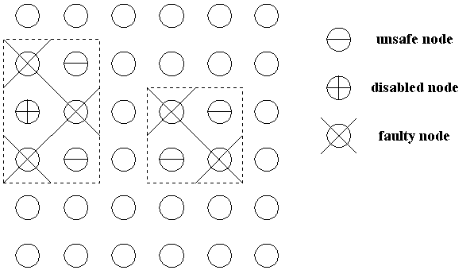
Figure 2 : faulty nodes, unsafe node, and disabled nodes

- Conclusion Remarks

 | Algorithm in [1] | Algorithm in [2] | Algorithm in [3]
Network | Hypercube | Hypercube | Hypercube
Virtual networks | 5 | 2 | 3
Faults tolerated | n-1 | ⎡n/2⎤ | n-1

 | Algorithm in [4] | Algorithm in [2] | Algorithm in [3]
Network | Mesh | Mesh | Mesh
Virtual networks | 4 | 2 | 3
Faults tolerated | block faults | disconnected block faults | block faults
Table 1 : Comparsion of some recently published algorithms
- G. M. Chiu and S. P. Wu. A fault-tolerant routing strategy in hypercube
multicomputers. IEEE Trans. Computers, 45(2):143-155, Feb 1996.
- C. C. Su and K. G. Shin. Adaptive fault-tolerant deadlock-free routing in
meshes and hypercubes. 1996
- This paper.
- R. V. Boppana and S. Chalasani. Fault-tolerant wormhole routing
algorithms for mesh networks. 1996

Created by : Chia-Hao Yang
Date : Oct 8, 1997
- Examples
- Consider a 4-dimensional hypercube as shown in Figure 1 of
section 3. If source node S=(0001) and destination node D=(1110).
Case 1: all the nodes are fault-free.
Path : 0001→0000→0010→0110→1110
Case 2: if nodes 0100, 0010, 1111, and 1000 are faulty.
Path : 0001→0011→0111→0110→1110

- Consider a 7x7 mesh as shown in Figure 3.
VC_{+0,1} in node X=(i,1), 0≤i≤6, is assigned 1 and VC_{-0,1} in node Y=(i,4), 0≤i≤6, is assigned 3. So, the detour VC_{+1,2} (or VC_{-1,2}) in node X belonging to detour_group_{+0,+1} (or detour_group_{+0,-1}) can be assigned within the range between 0 and 1. We choose 0.1, 0.2, and 0.3 (or 0.4, 0.5, and 0.6).

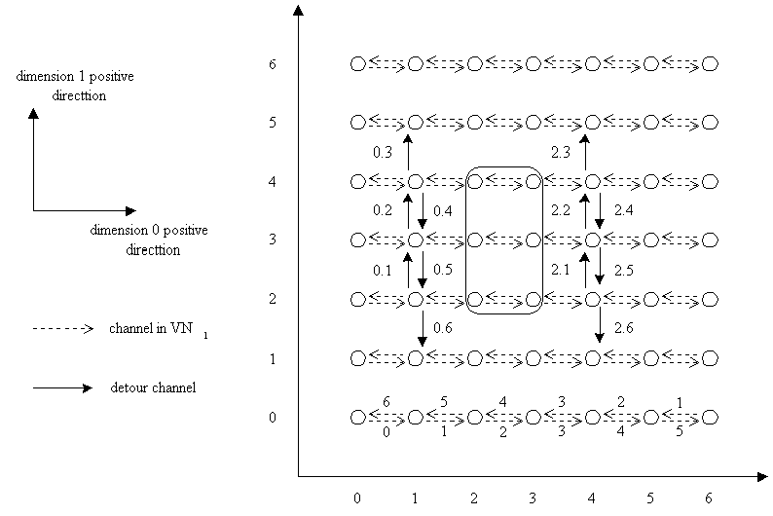
Figure 3. The detour channels of 7x7 mesh.
Created by : Chia-Hao Yang
Date : Oct 15, 1997

